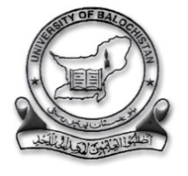
UNIVERSITY OF BALOCHISTAN, QUETTA.
Office of the University Advancement/Financial Aid.
Say No to Corruption

Ref No: _______________ Dated: ____________

Certificate

It is to certify that Higher Education Commission has released funds under Prime Minister’s Fee Reimbursement Scheme for Less Developed Areas (Selected Regions) against

Mr. ________________________________________
S/O ________________________________________
CNIC No:___________________________________
Amount Released: ____________________________
Amount Requested to HEC: ____________________

The actual tuition fee (of Masters, MS/M.Phil and PhD Programs)
On and Off Mandatory charges which includes Registration Fee/Enrollment Fee, Admission Fee, Examination Fee, Library Charges (non-refundable), Laboratory Charges, Research Related Academic Activities only.

The fee will not be refunded to the non-study heads like Transport Fee, Hostel Fee, Sports Fee, Endowment Fund, Equipment Fee, Health Fee or any refundable dues.

Case Analyst.

